Janeka Martin
TCN2 Task 1: Data Cleaning and Profiling

Part I: Data Profiling
A. Review the data dictionary in the attached "Employee Turnover Considerations and Dictionary" document and provide profile data by doing the following within a document:
- Identify the dataset’s number of records (i.e., rows) and number of variables (i.e., columns).
To identify the dataset's number of records, I imported the CSV file into Python and used the .shape method to display the dataset’s dimensions. The first value returned by .shape represents the total number of rows (records), and the second value represents the total number of columns (variables) (Larose and Larose).

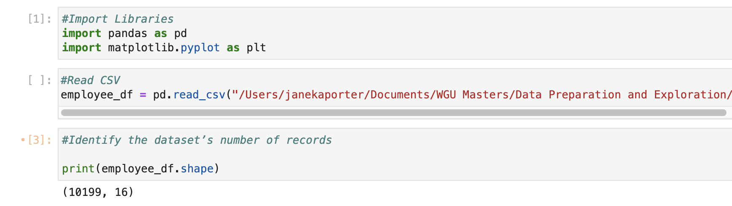

- List each variable and indicate the variable’s data type (quantitative/numerical or qualitative/categorical) and data subtype (i.e., continuous/discrete or nominal/ordinal).
Using the accompanying data dictionary, I reviewed each variable in the dataset and determined its data type, either quantitative/numerical or qualitative/categorical. I also identified its subtype, such as continuous, discrete, nominal, or ordinal.

Variable | Type | Subtype
Employee Number | Qualitative/ Categorical | Nominal
Age | Quantitative/Numeric | Discrete
Tenure | Quantitative/Numeric | Discrete
Turnover | Qualitative/ Categorical | Nominal
Hourly Rate | Quantitative/Numeric | Continuous
Hours Weekly | Quantitative/Numeric | Discrete
Compensation Type | Qualitative/ Categorical | Nominal
Annual Salary | Quantitative/Numeric | Continuous
Driving Commuter Distance | Quantitative/Numeric | Discrete
Job Role | Qualitative/ Categorical | Nominal
Gender | Qualitative/ Categorical | Nominal
Marital Status | Qualitative/ Categorical | Nominal
Number of Companies Worked | Quantitative/Numeric | Discrete
Annual Professional Development Hours | Quantitative/Numeric | Discrete
Paycheck Method | Qualitative/ Categorical | Nominal
Text Message Opt-In | Qualitative/ Categorical | Nominal

- Identify a sample of observable values for each variable.
To gather sample observable values for each variable, I examined the dataset in both Excel and Python. In Excel, I enabled filters to review the range of values within each column, and in Python, I used the .head() function to display sample entries from the dataset. These approaches helped me identify representative values for each variable.

Variable | Sample Data
Employee Number | 1,2,3
Age | 28,33,22
Tenure | 6,2,1
Turnover | Yes, No
Hourly Rate | $24.37, $98.07, $22.52
Hours Weekly | 40
Compensation Type | Salary
Annual Salary | 50689.6, 50689.6,46841.6, -28660.8
Driving Commuter Distance | 89,89,35, -5, -8
Job Role | Research, Human Resources, HumanResources, Human_Resources Information_Technology, InformationTechnology, Laborator, Healthcare
Gender | Female, Male, Prefer Not to Answer
Marital Status | Married, Singe, Divorced
Number of Companies Worked | 3,6,1, N/A
Annual Professional Development Hours | 7,7,N/A
Paycheck Method | Mail Check, Mail_Check, Mailed Check, Direct_Deposit, DirectDeposit
Text Message Opt-In | Yes, No, N/A

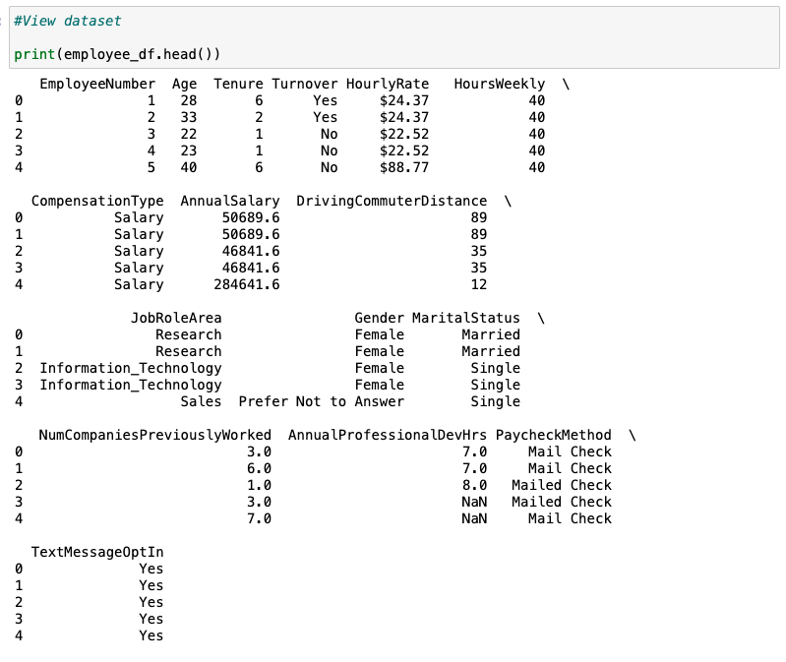

Part II: Data Cleaning and Plan
B. Using Python or R code data cleaning techniques do the following:
- Explain how you inspected the dataset to detect the following data quality issues:
- Discuss your findings for each quality issue listed in part B1.
C. Discuss which data cleaning techniques you used to correct all the data quality issues you identified by doing the following:
- Describe how you modified the dataset using Python or R code after identifying each quality issue listed in part B1.

- duplicate entries

As recommended by LinkedIn (n.d.), the best method to use in Python is .duplicated(). This function evaluates each row and returns True when a row is an exact match to a previous. Because Employee Number should uniquely identify each record, I further reviewed duplicates by sorting the data by Employee Number to confirm repeated observation.
VARIABLE NAME | B1. CODE SHOWING HOW I FOUND ISSUES(S) WITH THIS VARIABLE | B2. HOW MANY ISSUES I FOUND OF EACH TYPE | C1. CODE SHOWING HOW I MITIGATED THE ISSUE(S)
DUPLICATES (ALL VARIABLES) | # Check for duplicate rows  Print(employee_df.duplicated())  # Count total duplicates  Print(employee_df.duplicated().sum())  # Shows full duplicated row  duplicate_rows = employee_df[employee_df.duplicated(keep=False)]  # See which columns are actually duplicated by Employee Number  duplicate_rows.sort_values(by=["EmployeeNumber"]) | 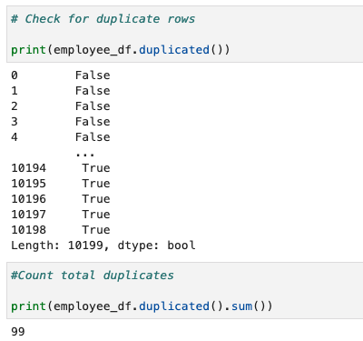 | #Remove duplicate records for the dataset  employee_df = employee_df.drop_duplicates()  #Confirm duplicates were removed  employee_df.duplicated().sum()
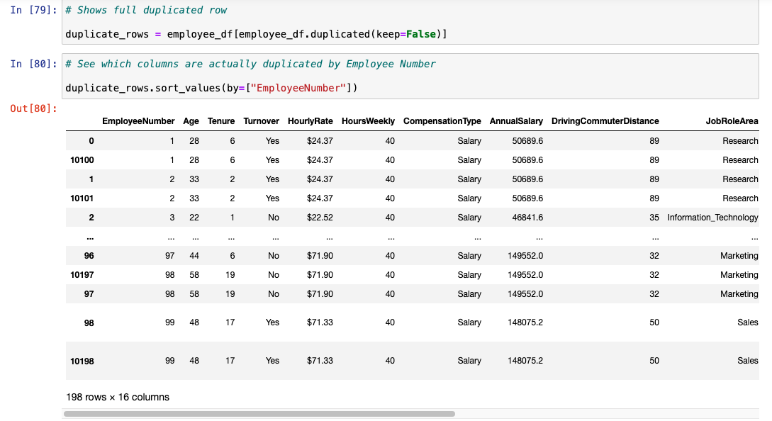

- missing values

To account for missing values, the technique used was df.isnull().any() and df.isnull().sum(). According to Klingensmith (2022), this function identifies missing values.
VARIABLE NAME | B1. CODE SHOWING HOW I FOUND ISSUES(S) WITH THIS VARIABLE | B2. HOW MANY ISSUES I FOUND OF EACH TYPE | C1. CODE SHOWING HOW I MITIGATED THE ISSUE(S)
MISSING VALUES (ALL VARIABLES) | #Check for missing values and count missing values using .any() or .sum()  print(employee_df.isnull().any())  print(employee_df.isnull().sum()) | 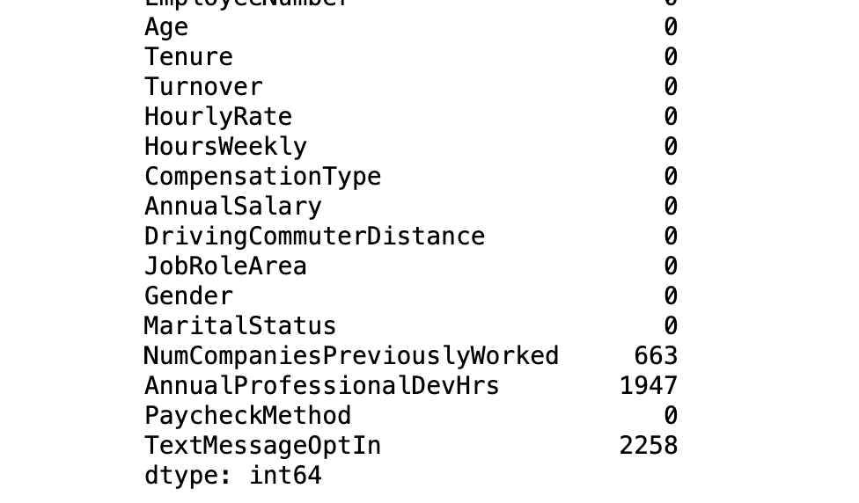  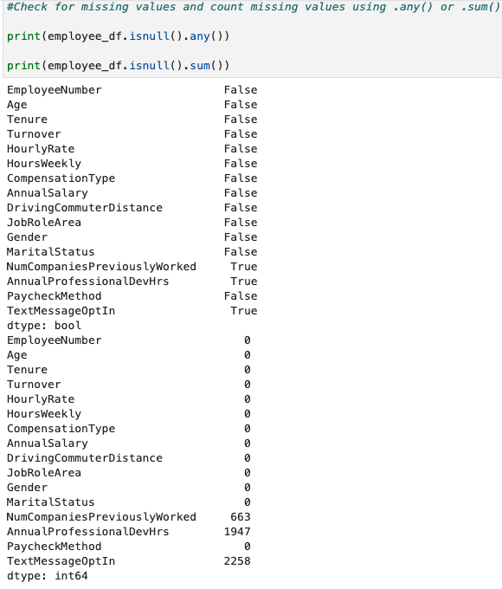 | #Update missing values found in numerical columns NumCompaniesPreviouslyWorked and AnnualProfessionalDevHrs columns with mean values  employee_df['NumCompaniesPreviouslyWorked'].fillna(employee_df['NumCompaniesPreviouslyWorked'].mean(), inplace=True)  employee_df['AnnualProfessionalDevHrs'].fillna(employee_df['AnnualProfessionalDevHrs'].mean(), inplace=True)  #Clean mean values for NumCompaniesPreviouslyWorked to round as nearest whole number  employee_df["NumCompaniesPreviouslyWorked"] = employee_df["NumCompaniesPreviouslyWorked"].round(0)  employee_df["NumCompaniesPreviouslyWorked"] = employee_df["NumCompaniesPreviouslyWorked"].astype(int)  #Update missing values found in categorical column TextMessageOptIn with mode values  employee_df["TextMessageOptIn"] = employee_df["TextMessageOptIn"].map({"Yes": 1, "No": 0})  employee_df["TextMessageOptIn"].fillna(employee_df["TextMessageOptIn"].mode(), inplace=True)  employee_df["TextMessageOptIn"] = employee_df["TextMessageOptIn"].map({1: "Yes", 0: "No"})  #validate to check for missing values  print(employee_df.isnull().sum())

- inconsistent entries
To inspect the dataset for inconsistent entries, I initially used a For loop in Python to print the unique values within each column, by iterating through employee_df.columns. Using .unique(), I was able to quickly review all observed categories and identify quickly issues such as misspellings, unexpected values and categorical mistakes across multiple variables at once. I still went through each column and conducted additional checks for inconsistent entries, in case there were values not uncovered from the .unique() method.

VARIABLE NAME | B1. CODE SHOWING HOW I FOUND ISSUES(S) WITH THIS VARIABLE | B2. HOW MANY ISSUES I FOUND OF EACH TYPE | C1. CODE SHOWING HOW I MITIGATED THE ISSUE(S)
EmployeeNumber | # Convert EmployeeNumber to numeric format to ensure correct format  employee_df['EmployeeNumber'] = pd.to_numeric(employee_df['EmployeeNumber'], errors='coerce')  # Check for NaNs created by invalid entries  print(employee_df['EmployeeNumber'].isnull().sum())  #Check for negative EmployeeNumber  print((employee_df['EmployeeNumber']<0).sum()) | 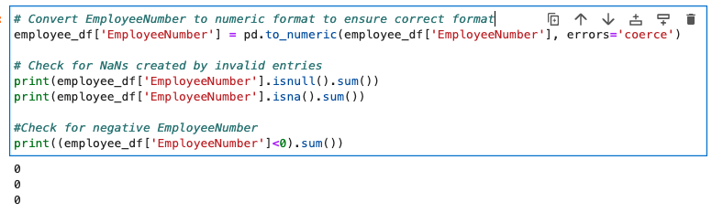  0 inconsistencies found | No mitigation necessary
Age | # Convert Age to numeric format to ensure correct format  employee_df['Age'] = pd.to_numeric(employee_df['Age'], errors='coerce')  # Check for NaNs created by invalid entries  print(employee_df['Age'].isnull().sum())  print(employee_df['Age'].isna().sum())  #Check for negative Age  print((employee_df['Age']<0).sum())  # Get min and max Age  min_age = employee_df['Age'].min()  max_age = employee_df['Age'].max()  print("Min age is:",min_age, "Max age is:", max_age) | 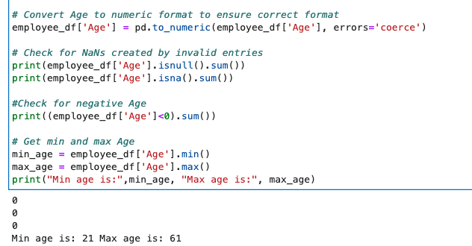  0 inconsistencies found | No mitigation necessary
Tenure | # Convert Tenure to numeric format to ensure correct format  employee_df['Tenure'] = pd.to_numeric(employee_df['Tenure'], errors='coerce')  # Check for NaNs created by invalid entries  print(employee_df['Tenure'].isnull().sum())  print(employee_df['Tenure'].isna().sum())  #Check for negative Tenure  print((employee_df['Tenure']<0).sum())  # Get min and max Tenure  min_tenure = employee_df['Tenure'].min()  max_tenure = employee_df['Tenure'].max()  print("Min Tenure is:",min_tenure, "Max Tenure is:", max_tenure) | 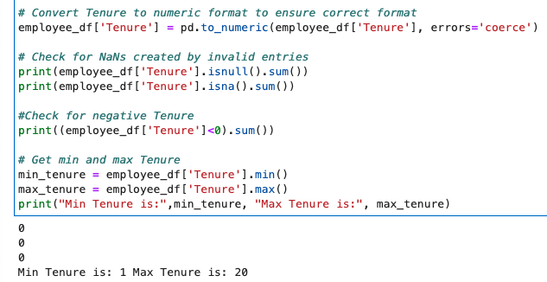  0 inconsistencies found | No mitigation necessary
Turnover | #For loop through each column to check for inconsistent records.  for col in employee_df.columns:  print(f"Column: {col}")  print(employee_df[col].unique())  print("\n") | 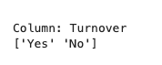  0 inconsistencies found | No mitigation necessary
HourlyRate | #For loop through each column to check for inconsistent records.  for col in employee_df.columns:  print(f"Column: {col}")  print(employee_df[col].unique())  print("\n") | 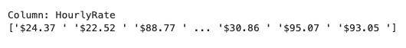  0 inconsistencies found | No mitigation necessary
HoursWeekly | #For loop through each column to check for inconsistent records.  for col in employee_df.columns:  print(f"Column: {col}")  print(employee_df[col].unique())  print("\n") | 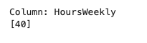  0 inconsistencies found | No mitigation necessary
CompensationType | #For loop through each column to check for inconsistent records.  for col in employee_df.columns:  print(f"Column: {col}")  print(employee_df[col].unique())  print("\n") | 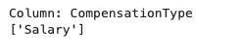  0 inconsistencies found | No mitigation necessary
AnnualSalary | #Check for negative Tenure  print((employee_df['AnnualSalary']<0).sum())  # Get min and max AnnualSalary  min_salary = employee_df['AnnualSalary'].min()  max_salary = employee_df['AnnualSalary'].max()  print("Min Salary is:",min_salary, "Max Salary is:", max_salary) | 57 salaries less than 0 found  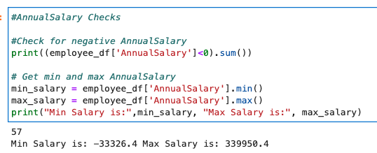 | #Replace negative salary values as absolute values  employee_df['AnnualSalary'] = employee_df['AnnualSalary'].abs()  #Validate negative salaries updated to absolute values  print((employee_df['AnnualSalary']<0).sum())
DrivingCommuterDistance | #For loop through each column to check for inconsistent records.  for col in employee_df.columns:  print(f"Column: {col}")  print(employee_df[col].unique())  print("\n")  #Confirm total negative DrivingCommuterDistance  print((employee_df['DrivingCommuterDistance']<0).sum()) | 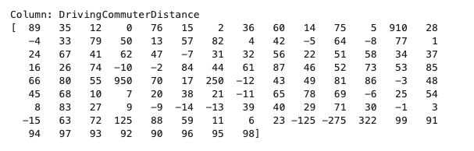  1,351 driving commuter distances less than 0 found  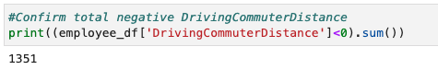 | #Remove negative commuter driving distances and make absolute values  employee_df['DrivingCommuterDistance'] = employee_df['DrivingCommuterDistance'].abs()  #Validate removing negative driving distances  print(employee_df['DrivingCommuterDistance'].unique())
JobRoleArea | #For loop through each column to check for inconsistent records.  for col in employee_df.columns:  print(f"Column: {col}")  print(employee_df[col].unique())  print("\n") | I found 208 inconsistent entries  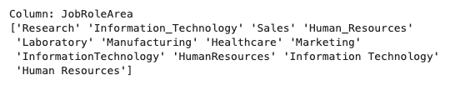  I found inconsistent spellings in the JobRoleArea column 'Information_Technology' or 'Information Technology' in the JobRoleArea column, HumanResources or Human_Resources etc.  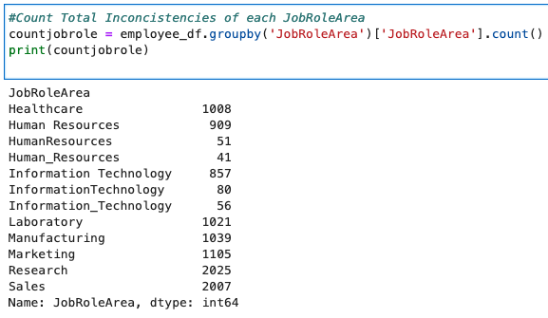 | #Fix Inconsistent spellings JobRoleArea  employee_df['JobRoleArea'] = employee_df['JobRoleArea'].replace({  'Information_Technology': 'Information Technology',  'InformationTechnology': 'Information Technology',  'Human_Resources': 'Human Resources',  'HumanResources': 'Human Resources'  })  #Validate Inconsistent spellings JobRoleArea fixed  print(employee_df['JobRoleArea'].unique())
Gender | #For loop through each column to check for inconsistent records.  for col in employee_df.columns:  print(f"Column: {col}")  print(employee_df[col].unique())  print("\n") |   0 inconsistencies found | No mitigation necessary
MaritalStatus | #For loop through each column to check for inconsistent records.  for col in employee_df.columns:  print(f"Column: {col}")  print(employee_df[col].unique())  print("\n") | 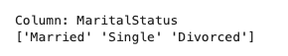  0 inconsistencies found | No mitigation necessary
NumCompaniesPreviouslyWorked | #Check for negative NumCompaniesPreviouslyWorked  print((employee_df['NumCompaniesPreviouslyWorked']<0).sum())  # Get min and max NumCompaniesPreviouslyWorked  min_companies = employee_df['NumCompaniesPreviouslyWorked'].min()  max_companies = employee_df['NumCompaniesPreviouslyWorked'].max()  print("Min previous companies worked is:",min_companies, "Max previous companies worked is:", max_companies) | 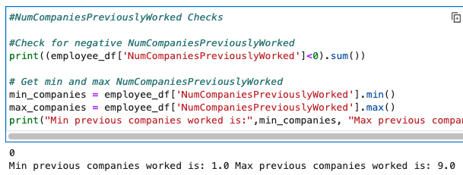  0 inconsistencies found | No mitigation necessary
AnnualProfessionalDevHrs | #Check for negative AnnualProfessionalDevHrs  print((employee_df['AnnualProfessionalDevHrs']<0).sum())  # Get min and max AnnualProfessionalDevHrs  min_hours = employee_df['AnnualProfessionalDevHrs'].min()  max_hours = employee_df['AnnualProfessionalDevHrs'].max()  print("Min hours is:",min_hours, "Max hours:", max_hours) | 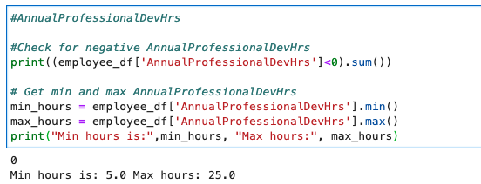  0 inconsistencies found | No mitigation necessary
PaycheckMethod | #For loop through each column to check for inconsistent records  for col in employee_df.columns:  print(f"Column: {col}")  print(employee_df[col].unique())  print("\n")  #Count Total Inconcistencies of each PaycheckMethod  countpay = employee_df.groupby('PaycheckMethod')['PaycheckMethod'].count()  print(countpay) | 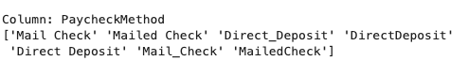  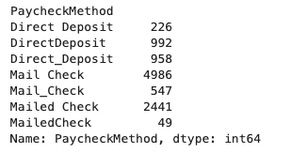  I found inconsistent spellings in the PaycheckMethod column including 'Mail Check', 'Mailed Check', or 'MailedCheck'. | #Fix Inconsist spelling in PaycheckMethod column  employee_df['PaycheckMethod'] = employee_df['PaycheckMethod'].replace({  'Mail_Check': 'Mail Check',  'MailedCheck': 'Mail Check',  'Mailed Check': 'Mail Check',  'Direct_Deposit': 'Direct Deposit',  'DirectDeposit': 'Direct Deposit'  })  #Validate PaycheckMethod Inconsistencies are corrected  print(employee_df['PaycheckMethod'].unique())
TextMessageOptIn | #For loop through each column to check for inconsistent records  for col in employee_df.columns:  print(f"Column: {col}")  print(employee_df[col].unique())  print("\n") | 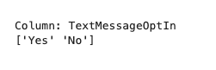  0 inconsistencies found | No mitigation necessary

- formatting errors
To inspect the dataset for potential formatting errors, I first reviewed the data types of each variable using the employee_df.dtypes function in Python. Numerical values stored as text became visible, which indicates improper formatting.

VARIABLE NAME | B1. CODE SHOWING HOW I FOUND ISSUES(S) WITH THIS VARIABLE | B2. HOW MANY ISSUES I FOUND OF EACH TYPE | C1. CODE SHOWING HOW I MITIGATED THE ISSUE(S)
FORMATTING ERRORS (ALL VARIABLES) | # Fix column header formatting issues (e.g., trailing spaces)  employee_df.columns = employee_df.columns.str.strip() | 1 column HourlyRate had trailing spaces | Upon loading the dataset all columns were cleaned to ensure removal of trailing spaces.
HourlyRate | #Review datatype for each column  print(employee_df.dtypes)  # For loop to review specifically object data type columns and ensure correct values are included.  for col in employee_df.select_dtypes(include='object').columns:  print(f"Column: {col}")  print(employee_df[col].unique())  print("\n") | 1 issue found. HourlyRate has the datatype object.  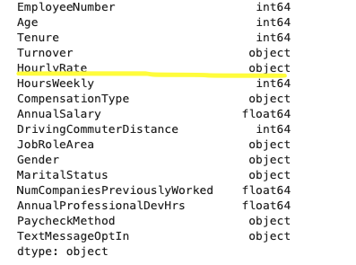  HourlyRate had formatting issues (currency/commas) that caused blanks; I removed symbols  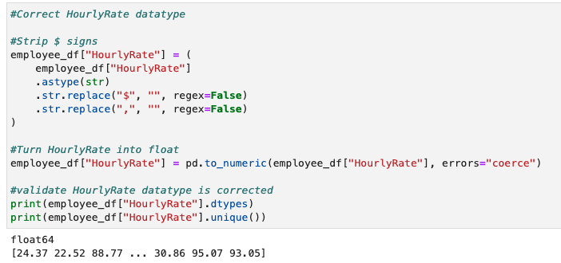 | #Strip $ signs  employee_df["HourlyRate"] = (  employee_df["HourlyRate"]  .astype(str)  .str.replace("$", "", regex=False)  .str.replace(",", "", regex=False)  )  #Turn HourlyRate into float  employee_df["HourlyRate"] = pd.to_numeric(employee_df["HourlyRate"], errors="coerce")  #validate HourlyRate datatype is corrected  print(employee_df["HourlyRate"].dtypes)  print(employee_df["HourlyRate"].unique())

- Outliers
To identify outliers in the dataset, I used the .describe () function in Python. This function enabled me to identify outliers using statistical tests for each numerical value. Each of the statistical values identifies values that are far outside the distribution. To visualize outliers, I generated boxplots for selected numerical variables to confirm values seen during .describe() analysis. According to Klingensmith (2024), boxplots are an effective way to better represent distributions of numeric data.

Figure 1:

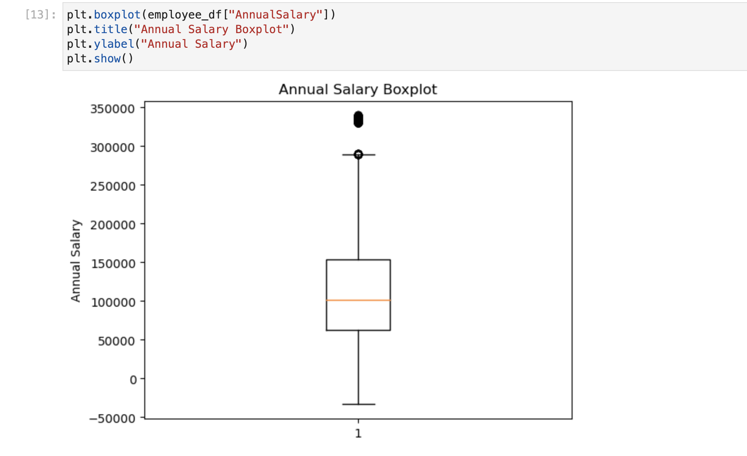

The boxplot for Annual Salary shows data points above the upper whisker, indicating salaries over $300,000. These values fall outside the expected distribution and represent outliers according to the 1.5 × IQR rule. (Klingensmith, 2024). In addition, I was able to see negative Annual Salaries in the box plot that need to be corrected, and that could indicate inaccuracies in the statistical analysis.

Figure 2:

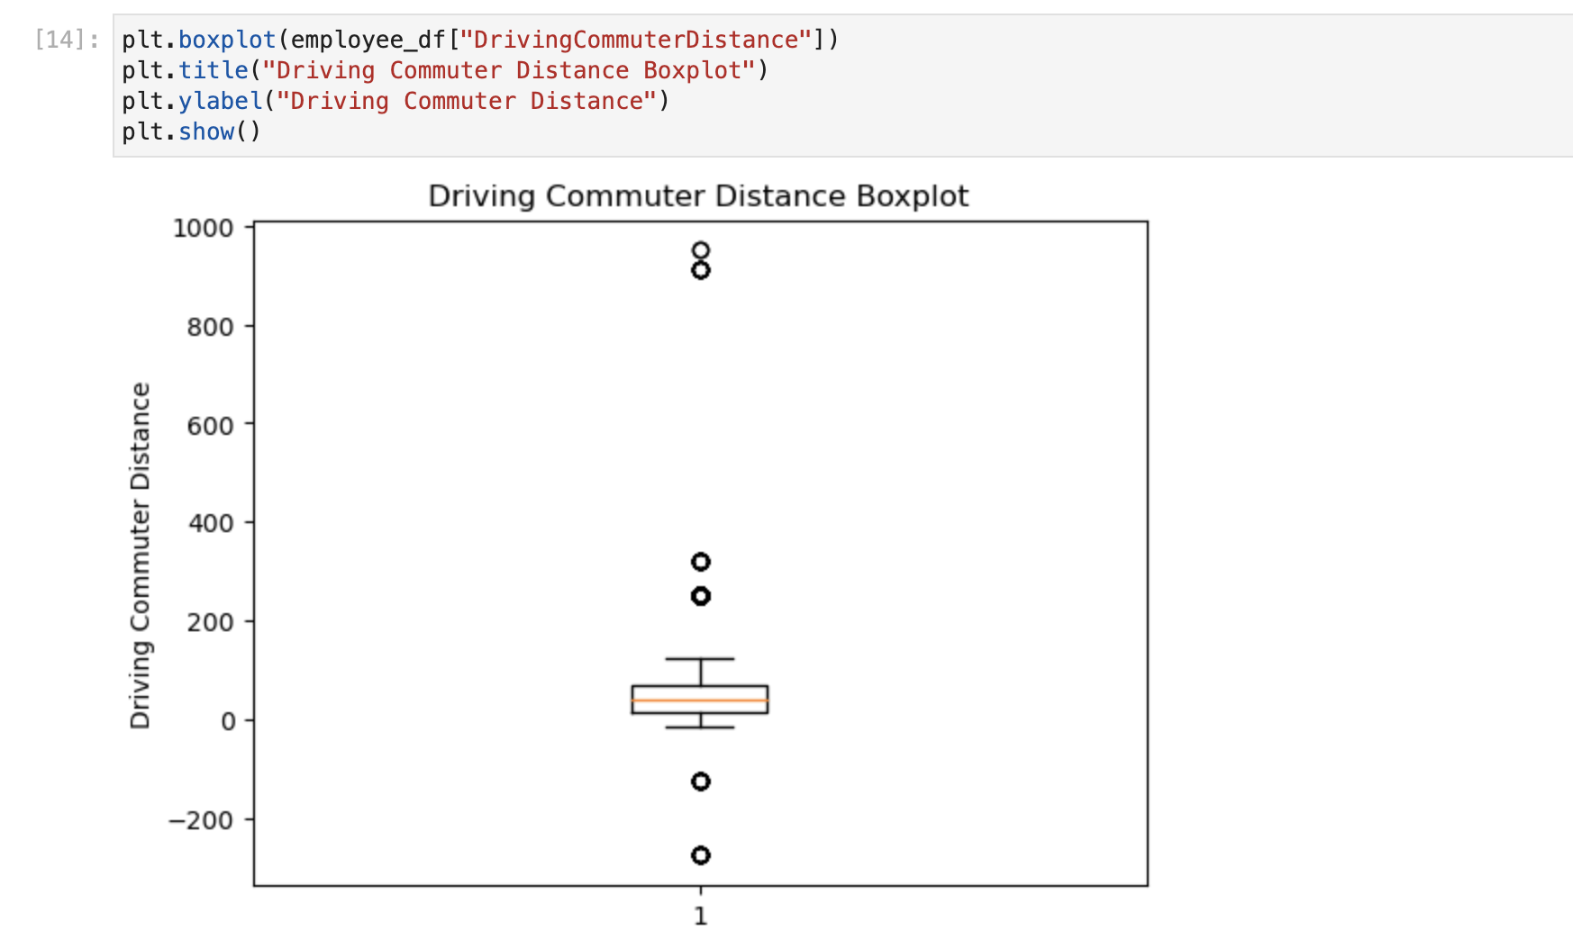

The boxplot for Driving Commuter Distance shows employees reporting commuting distances of 200-400 miles and 800-1,000 miles. These outliers are unrealistic, as they fall outside the top whisker. In addition, the values appear below the lower whisker, indicating formatting or entry errors that must be corrected or removed.

To assess the total number of outliers for the columns AnnualSalary and DrivingConmmuterDitance I took a count of all outliers found.

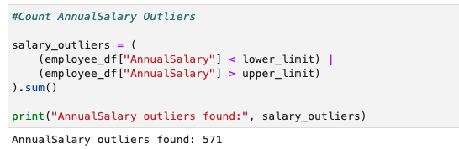

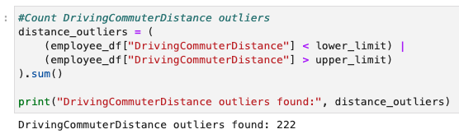

To address these unrealistic values while preserving the dataset, median imputation was applied to extreme salary outliers, as the median is less sensitive to extreme values and reduces distortion in subsequent analyses.

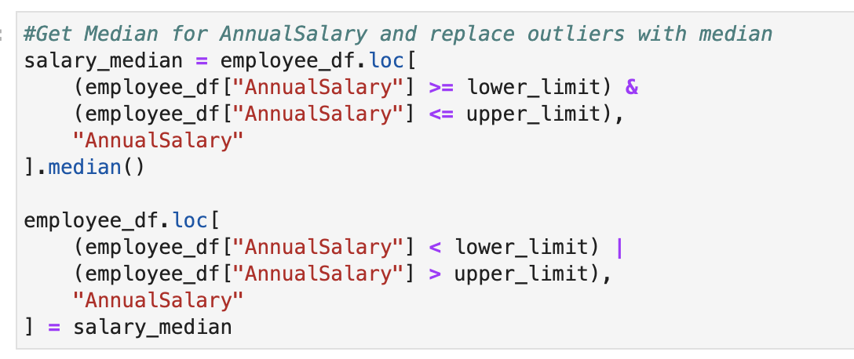
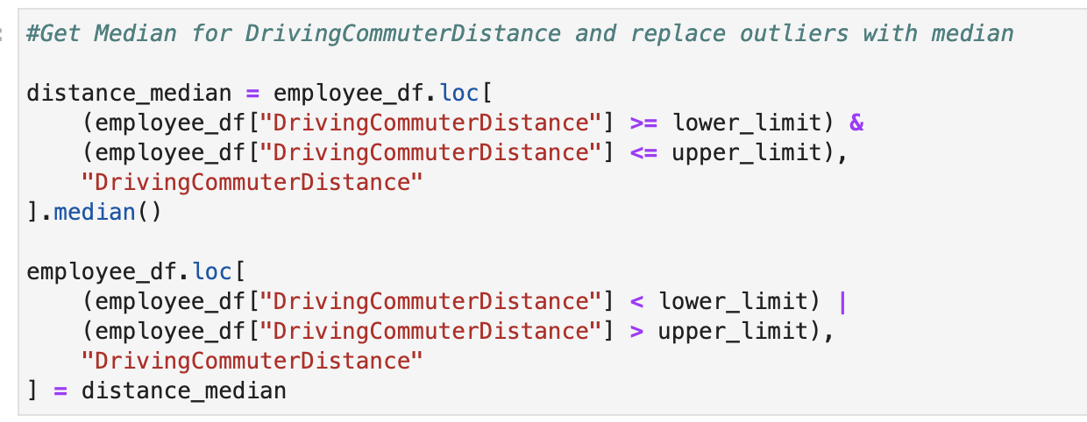

- Discuss why you chose the specific data cleaning techniques you used to clean the quality issues listed in part B1.

Duplicate entries:

The drop_duplicates method was chosen because it efficiently removes duplicate records while keeping a single instance of each. This technique is appropriate as it eliminates records with identical information.

Missing Values:

To address missing values, I applied the imputation techniques consistent the Univariate Imputation method. I used this method for selected numerical variables. Missing values in numerical columns with relatively stable distributions were replaced with the mean, preserving the overall distribution and the dataset size. Since NumCompaniesPreviouslyWorked represents a count variable, imputed mean values were rounded to the nearest whole number to maintain logical consistency within the dataset. For the TextMessageOptIn column, those missing values were replaced with the mode, which is the preferred Univariate Imputation method used when the variable is categorical or bimodal.

Inconsistent Entries:

Inconsistent entries were corrected that included entries such as misspellings, unexpected values and categorical mistakes across multiple variables at once. The columns JobRoleArea and PaycheckMethod I decided to make all values consistent so that Frequency results can be analyzed by the corrected categories and give the most accurate totals per the correct category. For the columns AnnualSalary,, negative values found were addressed by converting them to their absolute values. This approach was selected because the magnitude of these values appeared realistic when ignoring the negative sign, indicating that the error was likely due to incorrect sign entry rather than incorrect measurement.

Formatting Errors:

During review of each column in the dataset to ensure correct data types, the HourlyRate column was identified as an object data type. However, the values present were floating-point numbers. To correct this issue, I converted this column to a float64 datatype using Python’s .to_numeric() method. Converting the Hourly Rate variable to a numeric data type was necessary to allow accurate calculations, summary statistics, and visualizations. Storing numerical values as objects can lead to errors during analysis and limit the use of statistical methods.

Outliers:
To identify outliers I used a few methods such as .describe() to get the statistics for each column, I visualized outliers with box plots so I could more easily identify outrageous outliers and I used the IQR method to fin, count and replace outliers. I chose the median imputation method to reduce distortion in the distribution while preserving all records in the dataset.

- Describe two advantages to your data cleaning approach specified in part C1.
One advantage to note for the techniques chosen while cleaning the dataset, is that by ensuring values are consistent, complete, and properly formatted improves the overall accuracy and reliability of the dataset. A second advantage is that the cleaned dataset is well-prepared for future analysis and model building, as data quality issues that could introduce bias or errors have been mitigated.

- Discuss two limitations to your data cleaning approach specified in part C1.
One limitation of this data-cleaning approach is that removing duplicate records reduces the dataset's total number of observations, which may slightly affect the overall sample size. Another limitation is that, when using Univariate Imputation methods, such as replacing missing numerical values with the mean, the results rely on estimated values. If missing data is not randomly distributed, this approach may introduce bias.

Part III: Submission
D. Submit your findings by doing the following:
- Provide a data cleaning report as a document that includes responses to task prompts through the Assessments section of the student portal.
The report you are currently reading is the data cleaning report.

- Provide the error-free annotated code you used to detect and mitigate the data quality as an executable script file. R files and Python script files are accepted.
Link below to Python code:

https://gitlab.com/wgu-gitlab-environment/student-repos/jmart375/d599-data-preparation-and-exploration/-/blob/a1c0111e2d7f7814012715e515530cb5b3dbdf59/Data_Cleaning.ipynb

- Provide a copy of the cleaned dataset as a CSV file through the Assessments section of the student portal.
The cleaned dataset as a CSV is attached to this submission.

- Provide a link to a Panopto video recording that includes a demonstration of the functionality of the code used for the analysis and an identification of the version of the programming environment. The demonstration must include a vocal presentation of all the listed elements. For the duration of the presentation, ensure the video captures both you as the presenter and the functioning code in a Panopto video recording. Share this link through the Assessments section of the student portal.

The Panopto video recording is attached to this submission.
E. Acknowledge reference sources used to support the Python or R code application. All references listed should also include an in-text citation in the code annotation. Be sure the sources are reliable. If no sources were used for coding, state, “No sources used.”

Python coding techniques were informed by instructional resources provided by LinkedIn Learning and DataCamp, as cited in the references below.

F. Acknowledge sources, using in-text citations and references, for content that is quoted, paraphrased, or summarized.

Larose, Chantal D., and Daniel T. Larose. Data Science Using Python and R. Wiley, 2019. E-book.

LinkedIn (n.d.). Data-cleaning-in-python-essential-training. https://www.linkedin.com/learning/data-cleaning-in-python-essential-training-17061364/duplicates?resume=false&u=2045532
LinkedIn (n.d.). Python-for-data-science-and-machine-learning-essential-training-part-1. https://www.linkedin.com/learning/python-for-data-science-and-machine-learning-essential-training-part-1/removing-duplicates?u=2045532
Klingensmith, K. (2022, November 4). Handling Missing Data in Python. Towardsdatascience.com. https://towardsdatascience.com/handling-missing-data-in-python-c1ffe6e0f325/

Klingensmith, K. (2024, July 17). Python Boxplots: A Comprehensive Guide for Beginners. Datacamp.com. https://www.datacamp.com/tutorial/python-boxplots

